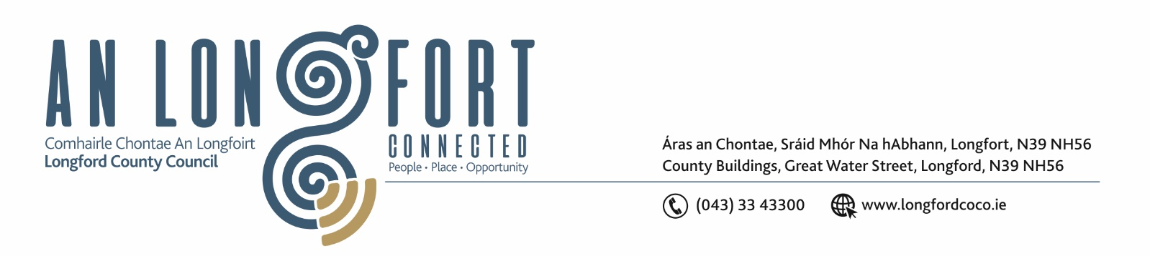
Please note meeting will be held via Microsoft Teams.

4u Feabhra 2021.

Chuig: Gach Ball don Chomhairle.

A Chomhairleoir,

Iarrtar ort bheith i láthair ag Cruinniú Míosuil Chomhairle Chontae Longfoirt a tionólfar via MS Teams are an Chéadaoin, 10u Feabhra 2021 ag 3.00 p.m chun gnó a dhéanamh d’réir an Chláir thíos.

You are requested to attend the Monthly Meeting of Longford County Council to be held via Microsoft Teams on Wednesday, 10th February 2021 at 3.00 p.m. to transact business, as set out on the Agenda hereunder.

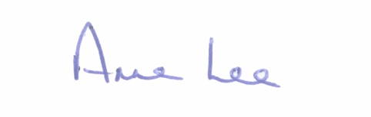
Mise le meas,

__________________
Anne Lee,
Meetings Administrator.

C L A R

Presentation by representatives from NBI (National Broadband Ireland)

- Confirmation of Minutes of Monthly Meeting of Longford County Council held on the
20th January 2021 – copy enclosed.

- Matters arising from Minutes.

- Declaration of Interest by Members.

4 . To note Management Report - to follow.

5. To note adopted Minutes of Corporate Policy Group Meeting held on the 9th December 2020 -
enclosed.

6. Finance & Regeneration.

- To note adopted Minutes of meeting of Governance Strategic Policy
Committee held on the 20th October 2020 - enclosed.

- Local Government Act 2001 - Annual Ethics Declaration.

- Commercial Rates Waiver – First Quarter 2021.

7 . Community, Corporate and Enterprise.

- To note adopted Minutes of meeting of Placemaking Strategic Policy
Committee held on the 19th October 2020 - enclosed.

- Item referred from Placemaking Strategic Policy Committee Meeting held on the
1st February 2021–

Consideration of the following amendment to the Business Incentive Scheme -
That the Business Incentive Scheme which was due to expire on 31st December, 2020 be
extended for another year but only for applications for new industrial/manufacturing type
businesses offering additional jobs. (An industrial expansion may also be deemed eligible if
it moves to a larger unit and results in additional jobs)

8. Strategic Infrastructure and Climate Change.

- To note Planning Applications received since last meeting of the Council.

- (i) To note adopted Minutes of meeting of Climate Action and Planning
Strategic Policy Committee held on the 21st October 2020 - enclosed.

(ii) To note adopted Minutes of meeting of Strategic Infrastructure
Strategic Policy Committee held on the 22nd October 2020
- enclosed.

- Consideration of the disposal of property at Carrollbrennan, Newtowncashel,
Co. Longford in accordance with the terms of Section 183 of the Local Government Act 2001 issued on the 26th January 2021.

- Notices of Motions, submitted by Councillors, as listed hereunder.

Councillor Uruemu Adejinmi.

“I call on the County Council to install contactless water filling stations in all Municipal Districts to limit single use plastic in the County.
The bottle filling stations will provide contactless, clean and safe water without the risk of touching high-use buttons that could increase the spread of infection. Users can simply place a water bottle into the holder and the sensors will pick up on movement and activate the machine.
The units also have digital water flow meters with remote monitoring built in, which monitors the output to determine the amount of plastic water bottles, which have been prevented from entering circulation in the County.
I have discussed this with Longford and Ballymahon Tidy Towns and they have indicated their interest and support for this project.”

9. General.

- Correspondence – enclosed.
- Correspondence received from the Office of the Minister for Justice regarding parental alienation.

10. Votes of sympathy.

